**Topic:** Eudoxus of Cnidos

**Notes on Topic:** Eudoxus is one individual mathematicians between Hippocrates and Euclid. He was born in 408 BC in Cnidos.  
He went to Athens about the time the Academy was founded by Plato. He attended lectured taught by Plato, whom was a student of Socrates.   
Eudoxus’ poverty forced him to live outside the city and travel everyday into Athens to attend school, making him one of the first known commuters   
Eudoxus was mostly interested in astronomy, he devised complex explanations of lunar and planetary motion, he never accepted mystical or divine explanation for natural phenomena, and subjected such to observational and rational analysis.  
  
His contributions: First, his theory of proportions. Second, the method of exhaustion.   
The theory of proportions was used in proving the once proven by the Pythagorean brotherhood theorems involving similar triangles, solving the “logical scandal” of Greek geometry, when the incommensurable lengths shattered the brotherhood proofs.  
The method of exhaustion immediately found application when determining the formula for area and volume of geometric figures: the general strategy was to approach an irregular figure by means of succession of known elementary ones. For example: a circle. Inscribe a square, double the square’s sides to make an octagon, then a 16-gon, we will find these regular polygons ever more approximating the circle. The polygons are “exhausting” the circle. This is a similar process that Archimedes chose to determine the area of the circle.   
  
Archimedes credited Eudoxus with using his method of exhaustion to prove that the volume of “any cone is one third part of the cylinder which has the same base with the cone and equal height”.   
The geometric forerunner of the modern notion of the limit involves the method of exhaustion as well.   
  
Eudoxus’ contribution was significant, he is regarded as being the finest mathematician of antiquity next to Archimedes.  
  
**In Class Activity**: Look at the Geometric limit and how method of exhaustion is used

The idea, start with a circle, with an inscribed square, keep increasing the number of sides of the regular inscribed polygon, as the number of sides increase, the area of the polygon approaches the area of the circle. Eventually, it was thought, that the polygon would have so many sides that it would be a circle (we know that this, in reality, is impossible, but it is a valid way to approximate the area of a circle).

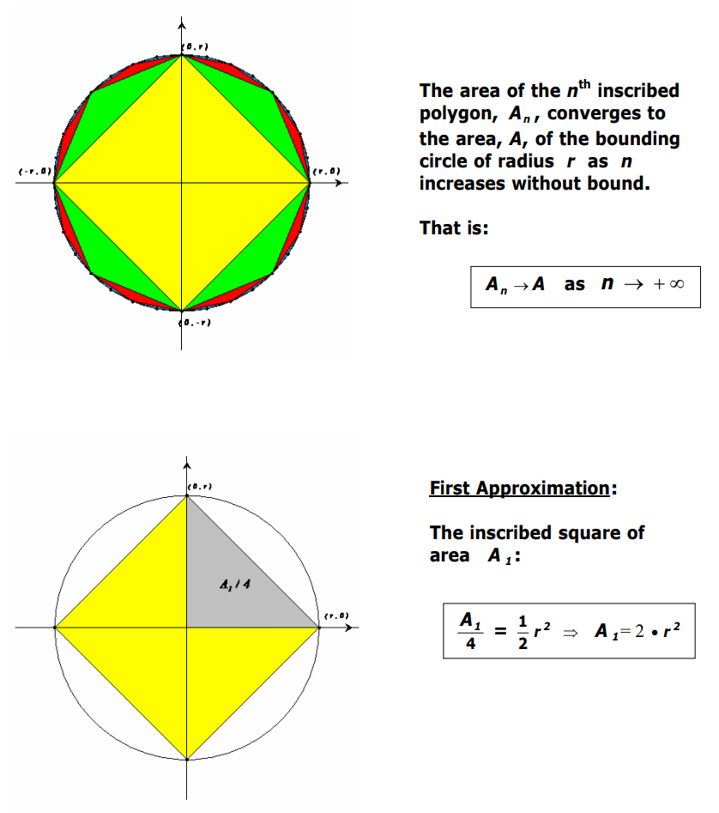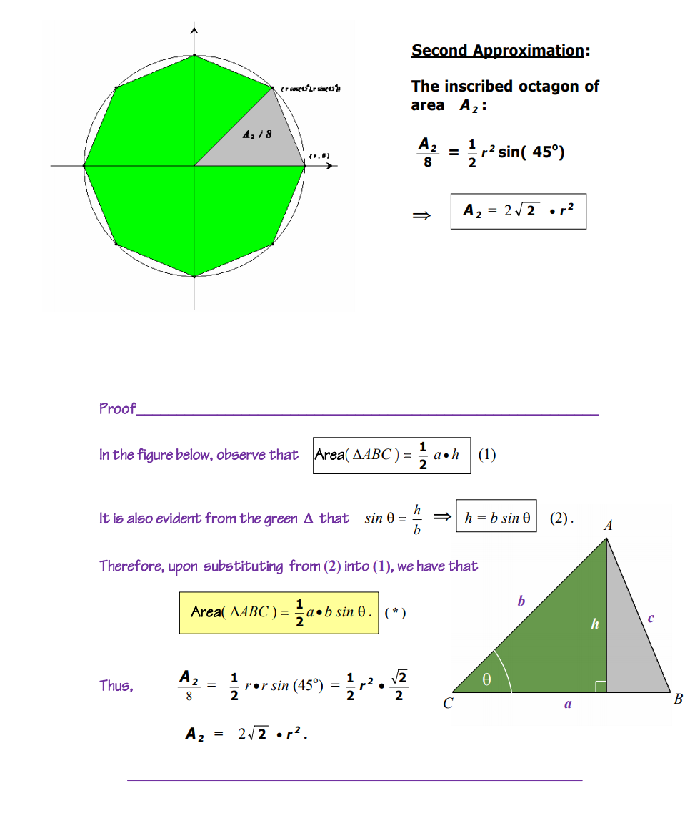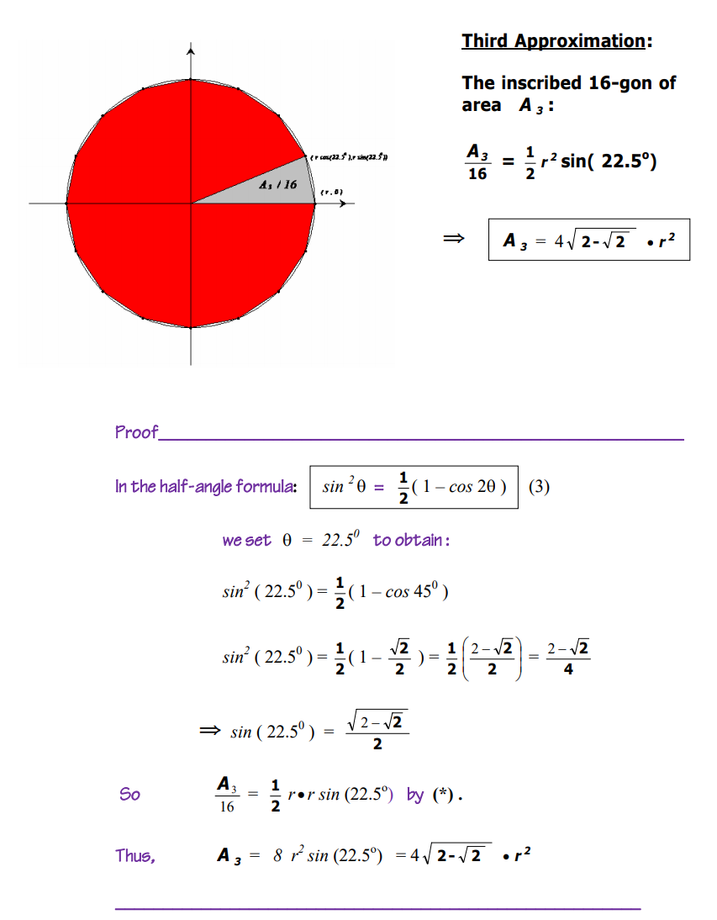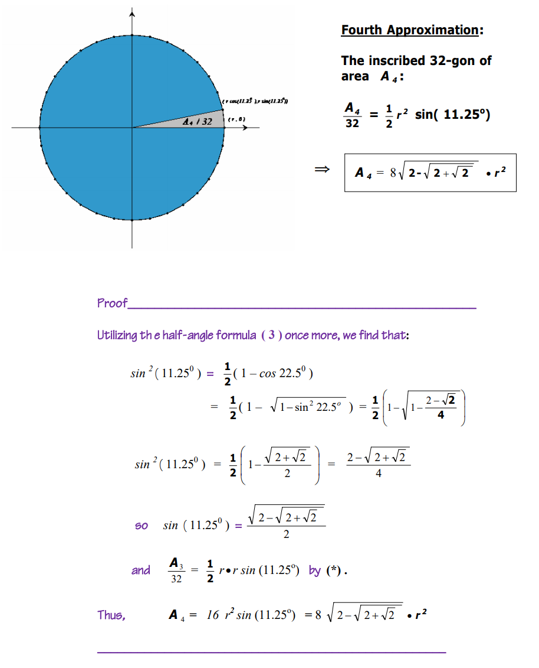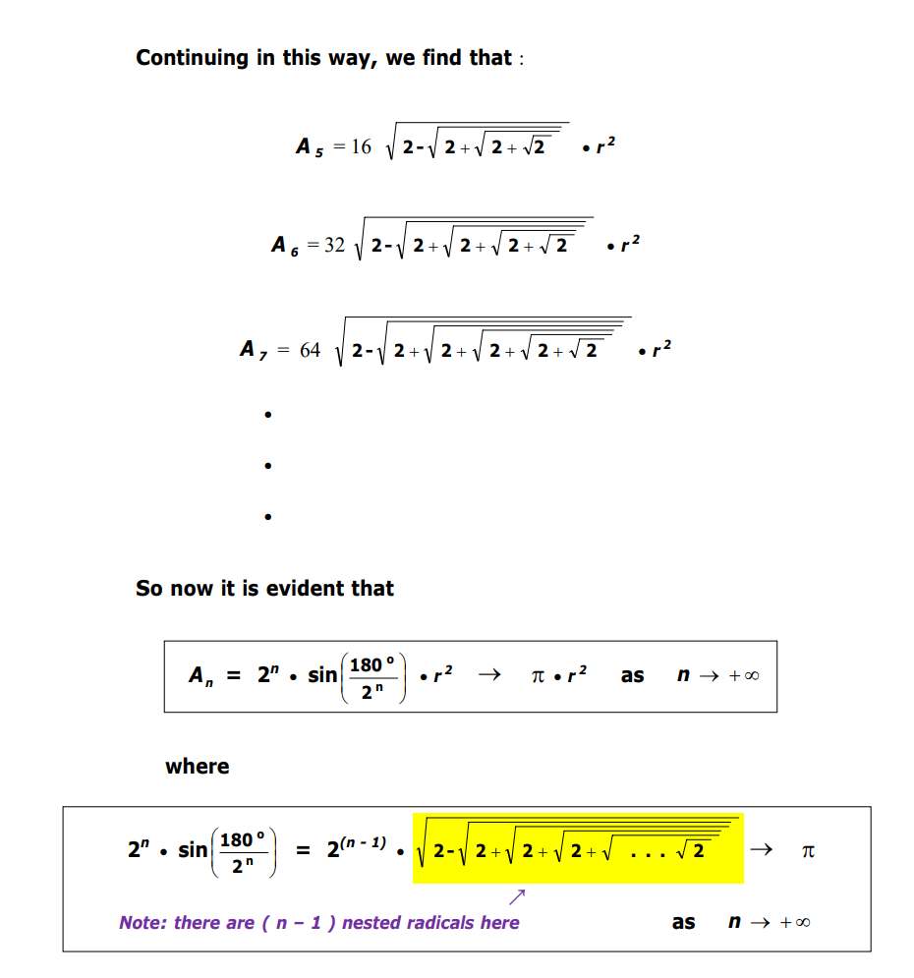

**Additional Suggested Reading**: http://mypages.iit.edu/~maslanka/Math122notes1.pdf

**Assignment:** None